**Resident Survey Analysis**

**Background & Purpose:**

The Miami Resident Survey is a critical component of the strategic planning process. The surveyhelps the City prioritizegoals andmeasure satisfaction with services. As part of our data analysis efforts, we would like to further explore the survey results through the use of data visualizations.

We invite all employees who took Power BI training to explore resident data and practice the skills learned. This is also an opportunity to dig into how residents are responding to your service area.

**What You Need:**

* **2017 survey instrument (attached)**
* **2017 survey results/raw data (attached)**
* **Instructions: “Data & Analytics in Practice” pg 64 – 85 [Power BI specific] (attached)**
* **Power BI: Download the free version:** <https://powerbi.microsoft.com/en-us/get-started/>

**Getting Started:**

1. Choose at least 4 resident survey questions to analyze through data visualization:
   1. Review the survey instrument (see attached) for questions of interest.
      1. See the screenshot below for examples of survey questions:

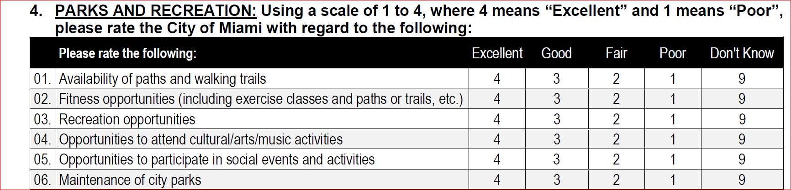

1. After you identify the questions and results you would like to analyze, upload the data set (see attached excel document) into Power BI desktop (for a referesher see pages 64 - 85 in the attached document named “Data Analytics in Practice”.
2. Submitting your visualizations**:** 
   1. After you finish your charts in Power BI, you can save them as Power BI File format, see image below. Send it to [strategicplanning@miamigov.com](mailto:strategicplanning@miamigov.com)

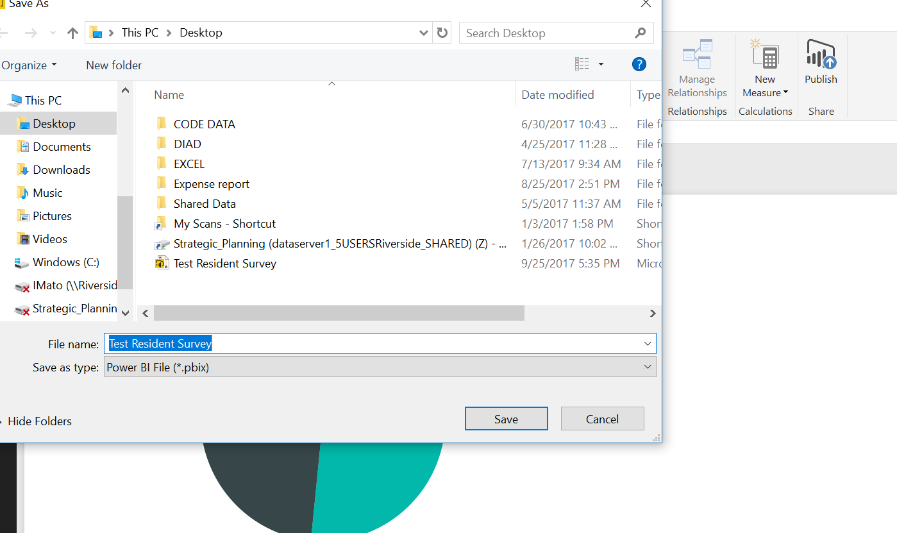

**Data Field Basics**

All questions are numbered the same in the questionnarie and raw data, see images below.

For example: “Overall Ease of Getting to Places You Have to Visit” is question number 1.

The results of the question range from “Essential” to “Not at All Important.” Note how each response has a number assigned ranging from 4 to 1:

**4**=Essential

**3**=Very Important

**2**=Somewhat Important

**1**=Not at all Important

**9**= “Don’t Know” or didn’t respond.

**Rating Questions**

4=Excellent

3=Good

2=Fair

1=Poor

9= Don’t know

**Survey Instrument Format**

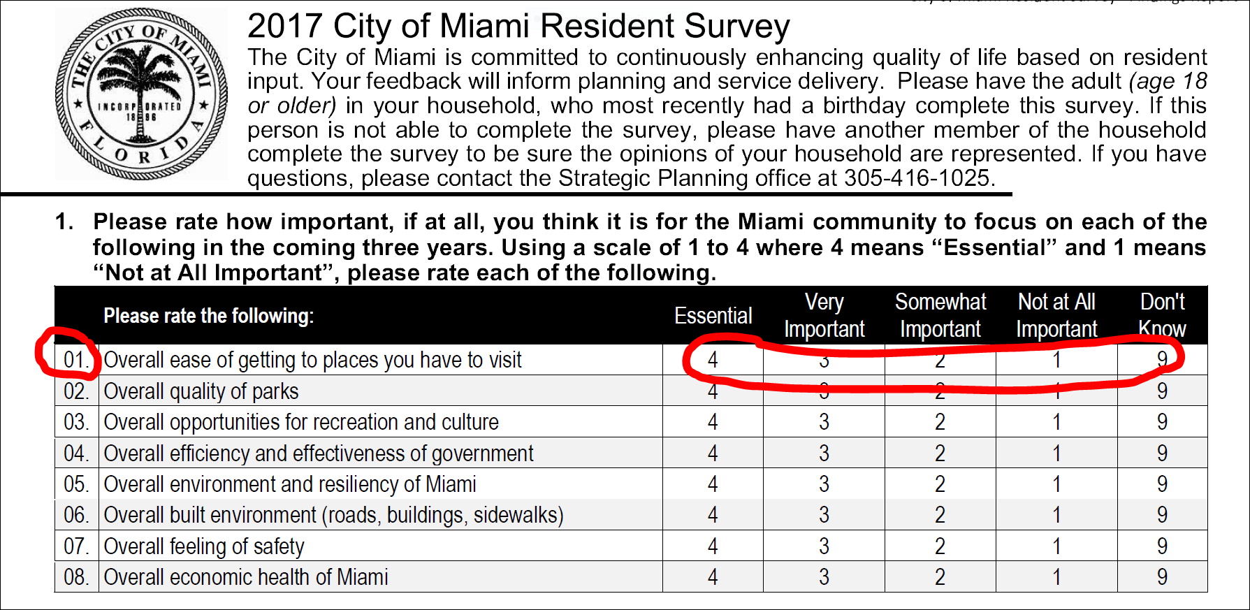

**Raw Data Format**

